ENGL11o1S  Syllabus |   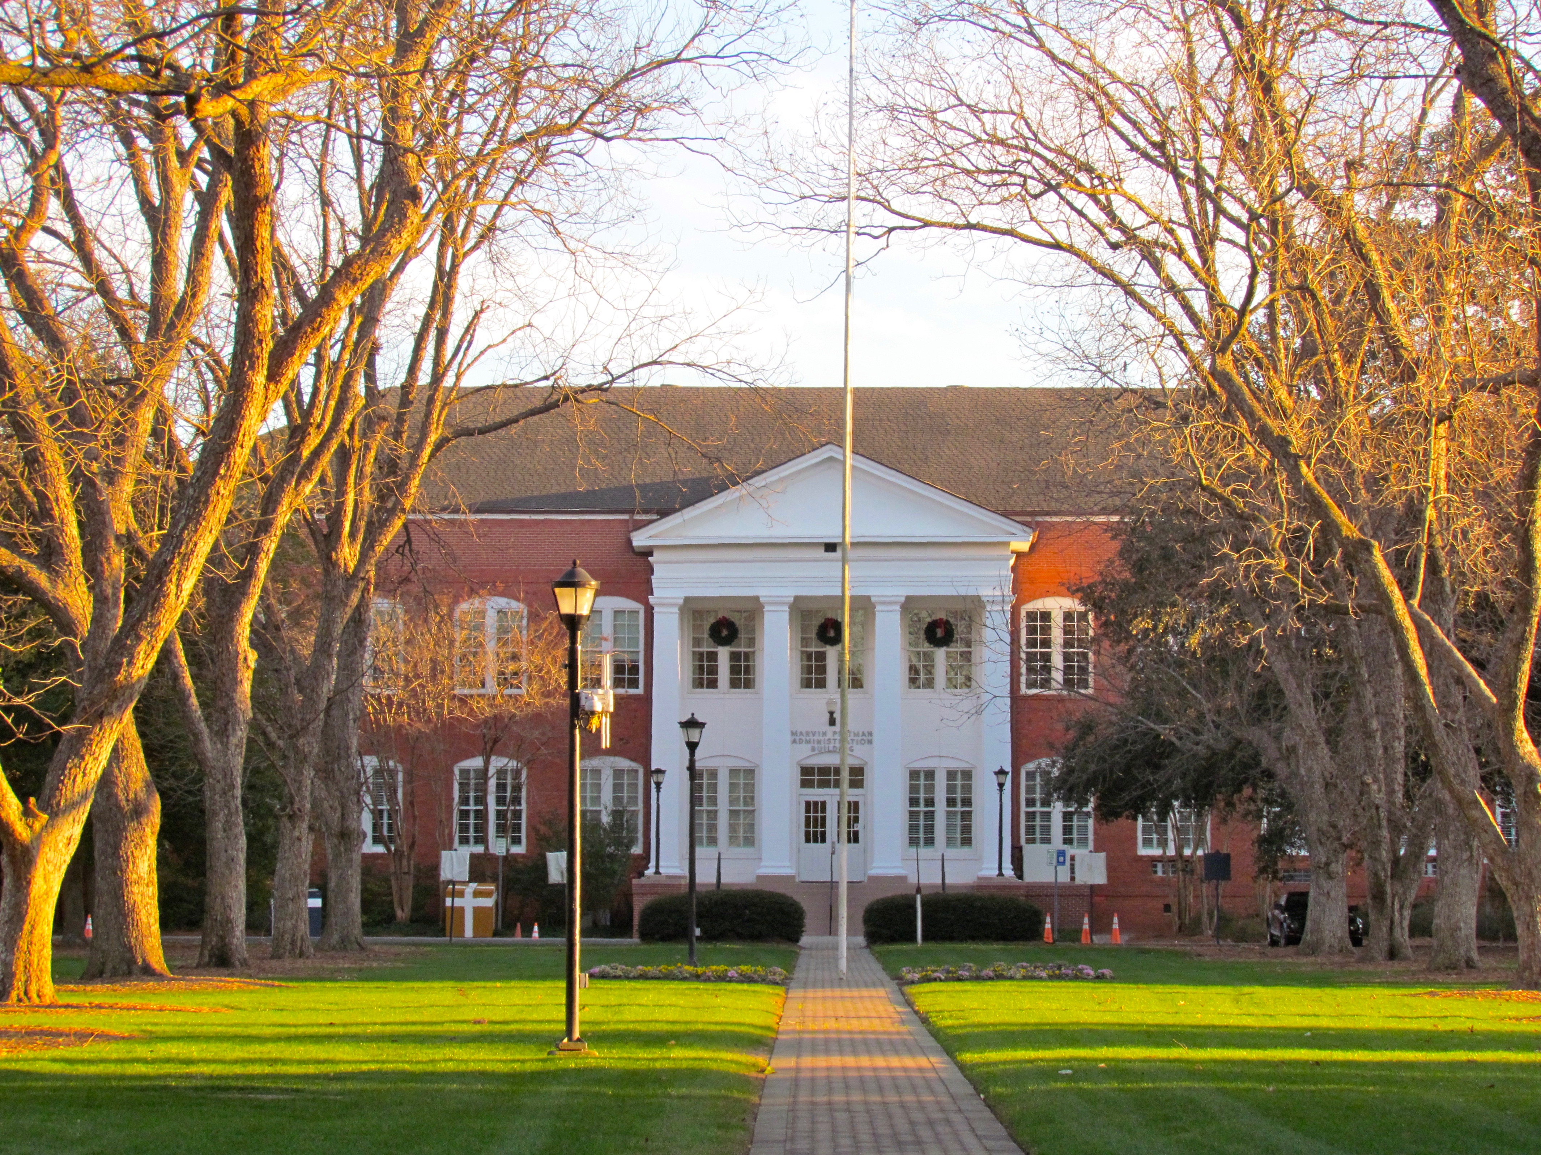
 | 

  - 5-6:15 p.m.
Table of Contents

2…About ENGL1101
2-7…Assignments and Grades
7-9…Communicating with Me
9-11…Attendance and Contributions to Class
11…Academic Integrity
11-13…Additional Policies
13…Important Dates
  - Tuesday: Newton 2209
  - Thursday: Newton 2210

  - Fall 2018 CRN 80895

  - Monique Bos, Professor
  - Office: 1123 Newton Building
  - Office Hours: MW 1:15-2:15 p.m.
  - TR 2:15-3:15 p.m.
Welcome to ENGL1101! Our theme this fall is “monsters and fantastic creatures,” and we’ll use this as a framework to strengthen critical reading, build research skills, and develop an effective writing process.

About English 1101

Student Learning Outcomes (SLOs)
The Department of Writing and Linguistics at Georgia Southern has established common Student Learning Outcomes (SLOs) for English 1101 and 1102. In ENGL1101, students learn to…

- Develop flexible strategies to achieve a defined purpose for writing
- Compose texts to examine their ideas in relation to those from a range of sources
- Respond to various rhetorical situations and genre conventions.

Required Materials

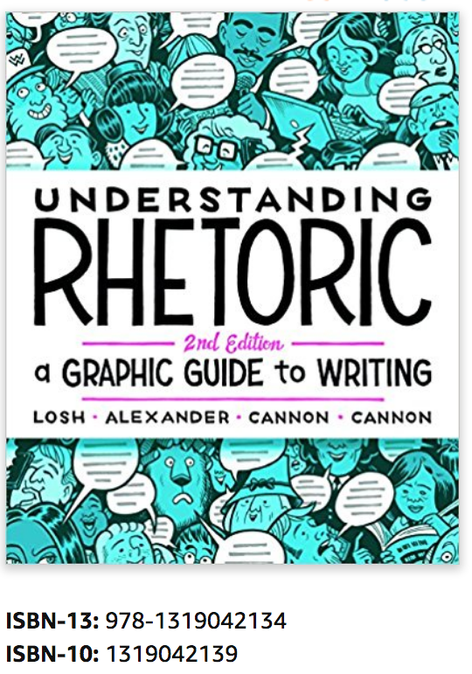
Textbooks:
Understanding Rhetoric (2nd edition) by Elizabeth Losh, Jonathan Alexander, Kevin Cannon, and Zander Cannon
ISBN-13: 978-1319042134
ISBN-10: 1319042139
Monsters: A Bedford Spotlight Reader, edited by Andrew J. Hoffman
ISBN-13: 978-1457690303
ISBN-10: 1457690306
Other readings will be posted to Folio. Please bring a notebook and pen to class to take notes.
Assignments and Grades
This semester, we’ll complete four major papers, as well as reading responses, draft critiques, and draft reflections. Please expect to have written work due every class period, and manage your time accordingly. (Per university standards, students should allocate two hours for work outside of class for every hour spent in class.) This means planning time each week to complete assignments. I don’t encourage or enable you to work very far ahead of the course schedule, both because we can have a more productive class discussion if readings are still fresh in your mind and because many of the reading responses and papers build on previous assignments and class discussions.

I’ll provide more information about assignments — including grade breakdowns, specific requirements and expectations, and due dates — as the term progresses. However, here’s a brief overview of the major assignments and grading criteria so you have an idea of what to expect:

Papers
Generally, your papers will be assessed for content (depth, clarity, and development of ideas; quality of sources and research, when appropriate), readability (organization, grammar, mechanics, punctuation, spelling, etc.), and process (whether you meet benchmarks). Grades are based on whether writing exceeds, meets, or doesn’t meet expectations in each category.

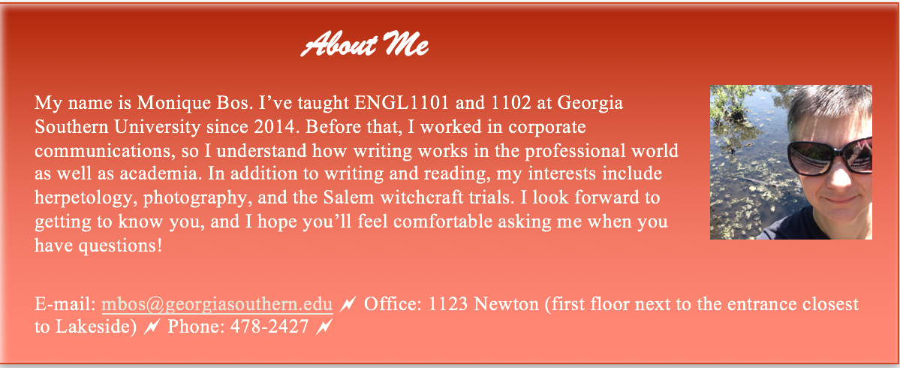

Paper 1 (SLOs 1 and 3): Your first assignment, tentatively due Week 5, will be a narrative that introduces you to your peers and me. Paper 2 (SLOs 1, 2, and 3): As we move into our thematic readings, you’ll reflect on a monster or fantastic creature that intrigues, fascinates, repels, or disgusts you. You’ll be required to find and incorporate credible, appropriate sources, and this assignment must follow APA style (which we’ll discuss in class). You may incorporate multimedia elements. This assignment tentatively will be due Week 9. Paper 3(SLOs 1, 2, and 3): For this assignment, you will analyze a book, film, TV show, video game, comic book, or other work related to a monster or fantastic creature. Again, you’ll be required to find and incorporate credible, appropriate sources. This paper must follow MLA style (which we’ll discuss in class) and is tentatively due Week 12. Paper 4 (SLO 2): The final assignment asks you to reflect on your own writing throughout the course of the semester. What have you learned? How have you grown? What strengths have you identified? What areas do you still need to improve? What are your goals and priorities as you move into ENGL1102? You may use either APA or MLA style but must follow one consistently. This paper will be due at our last class meeting.

Note: Unless otherwise specified on the schedule, all papers are due by the start of class time on the due date, NOT at 11:59 p.m. They must be submitted to the Folio dropbox AND to me as a printed copy. I require both because I check the originality report generated by turnitin.com via the dropbox (see Academic Integrity policy), post grade breakdowns in the Folio Comment section, enter grades in the Folio Gradebook, and provide written feedback on the printed copy. Thus, failure to provide all materials and/or to submit the paper in both formats may result in delayed grading and/or a late penalty of 10% per day, up to 50% of the paper grade, especially if incomplete submissions become habitual.

When you submit the final paper, please place it in a manila envelope or folder, and include all drafts and critiques from your peers and me. In order to fully assess your writing process, I need to see the critiques you were given and the ways in which you incorporated (or chose not to incorporate) specific feedback during the revision stage. Thus, failure to include drafts and critiques will adversely affect your final grade.

Your papers must be formatted in the following ways (which adhere to both MLA and APA style):
- One-inch margins on the top, bottom, and left side; ragged right margins set at one inch
- 12-point Times New Roman font
- Double-spaced

Papers for this course don’t need to be stapled, and double-sided printing is fine.
If you need an extension, please contact me at least 24 hours before the paper is due. I will grant extensions after the deadline only for documented, extenuating circumstances and only after consultation with you. I reserve the right to deny an extension, especially if the request is made less than 24 hours in advance and/or late work has become habitual. You must receive my written approval for any extension. I typically do not accept late work unless an extension has been arranged or the student has provided documentation of approved, extenuating circumstances.

Reading Responses
To encourage your preparation for and participation in class discussions, I’ll provide you with questions or prompts that ask you to “examine [your] ideas in relation to those” of assigned texts. Reading responses must be typed, unless otherwise specified, and are due to the online dropbox by the beginning of class on the due date.

You do not need to submit a printed copy of your reading responses, but I recommend that you bring one for your own reference, especially on days we do not meet in the computer lab, so you can remember your ideas and participate fully in the class discussion.

I assess reading responses on a 10-point scale, according to the following criteria:

Points | Criteria
9-10 | Exceeds expectations: The writer demonstrates through reading and engagement with the text and thoughtful, nuanced responses. (This can include asking questions about areas of confusion, concern, or disagreement.) Writing contains minimal grammatical, mechanical, punctuation, spelling, and/or syntactical errors.
6-8 | Meets expectations: The writer demonstrates familiarity with the main ideas in the text and provides competent answers, AND/OR the writing contains numerous grammatical, mechanical, punctuation, spelling, and/or syntactical errors that do not obscure meaning.
0-5 | Does not meet expectations: It isn’t clear to the reader (me) whether the writer read and understood the text. Answers are brief, elliptical, or cursory, or the writer skipped some questions completely; AND/OR the writing contains grammatical, mechanical, punctuation, spelling, and/or syntactical errors severe enough to obscure meaning.

Because the purpose of reading responses is to foster conversations with your classmates, I do not accept late reading responses or those submitted on days you miss class. (I may occasionally make exceptions for extenuating circumstances with appropriate, timely documentation; see Attendance policy.)

Notes About Assignment Submissions and Grade Turnaround
Due dates are posted to the schedule on the course website. You’re responsible for keeping track of deadlines and following the procedures spelled out in the syllabus and in assignment instructions. Please consult the schedule and pay attention in class for updates; do not rely on the Folio calendar or dropbox closing times to alert you to deadlines.

For this course, submissions to the online dropbox must be in Microsoft Word. Folio and turnitin.com cannot process many other file types, and I can’t check word count on PDFs. If you submit Pages*, PDF, or .rtf files, I’ll ask you to resubmit a Word document. Because incorrect file formats delay the grading process, at my discretion I may impose a late penalty of 10% per 24-hour period if you do not submit the paper in the required format.
* Pages is the default program installed on Apple computers (MacBooks, etc.). It is easy to save Pages files as Word documents; a Google search will provide you with step-by-step instructions. As a Georgia Southern student, you also have free access to MS Office, including Word. Simply go to Technology Resources on MyGeorgiaSouthern, select Download Software, and follow the steps to install Office365.

To ensure that you receive credit for your work, please do the following:

- Double-check that you submitted to the correct dropbox. It is not my responsibility to check multiple dropboxes to find your submission.
- When you successfully submit a file to Folio, you receive a confirmation e-mail to your Folio account. Keep this message. It’s crucial in the (unlikely but possible) event that a technical glitch causes your work to disappear from the dropbox. If you don’t receive a confirmation, you should assume that your submission didn’t upload, and try again.
- If you don’t see the appropriate dropbox, please contact me ASAP.

Under normal course circumstances, I strive to post grades and provide written feedback on papers within two weeks of submission, when possible and when all required elements are submitted on time (digital copy, print copy, drafts, and critiques). Incomplete submissions and work given an extension are not subject to this policy and will be graded as soon as possible before the end of the semester.
I strive to post reading response grades within a week of the due date.

Draft Workshops, Conferences, and Revisions
Drafts (and significant revisions) are an integral part of the writing process, so we’ll go through a critique process for each paper before you submit the final. You’re expected to participate in draft workshops, in which you comment on your peers’ work in progress and receive critiques on your own paper. The purpose of this kind of peer review isn’t to “fix” errors but to ask incisive questions and make suggestions that will help the writer polish their language and ideas. I hope you will view these workshops as valuable opportunities for feedback that can help you improve as a writer.
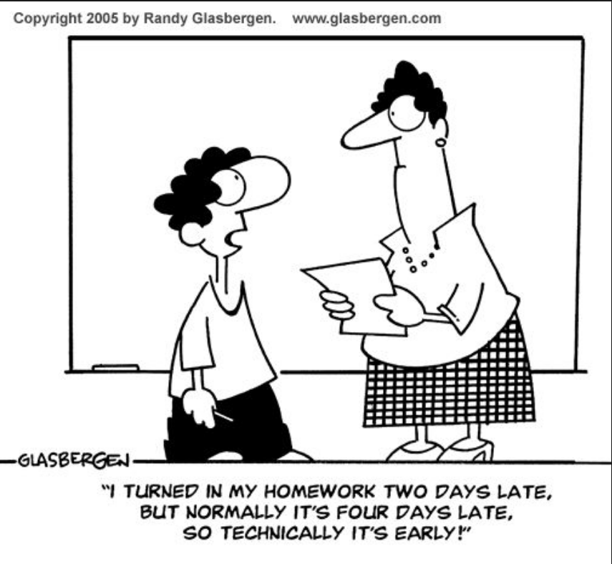
For each draft, I’ll provide requirements (word count, number and type of sources, due dates). Please submit printed copies (I’ll specify the number for each workshop) to share with peers and also to upload a digital copy to Folio. Unless otherwise noted, drafts are due the class period prior to the workshop.

Draft workshops operate best when everyone is prepared, thoughtful, and focused. As a member of our class learning community, please ensure that you

- Submit a draft that meets requirements (eg word count, sources) by the deadline
- Arrive on time
- Offer thoughtful, constructive feedback

Your participation in the workshop is contingent on meeting these requirements. If you’re absent or unprepared on a workshop day, you’re responsible for taking initiative to secure the required number of critiques from your peers in this class. Your classmates are familiar with assignment requirements, as well as the concepts we’ve discussed during each unit, so they’re uniquely qualified to critique your work. If your absence is for a legitimate, unavoidable reason (see Attendance policy), you’re not exempted from obtaining or participating in critiques, but with timely documentation, I’ll work with you to make arrangements on a case-by-case basis.

For at least one paper, you and I will hold individual conferences to discuss your work in progress. I don’t give you a checklist to achieve a certain grade, but I do ask questions and provide feedback designed to help you grow as a writer. Please come prepared to take notes. Apart from conferences, I can critique one person’s full draft only if I can critique every draft that’s submitted on time and meets requirements. However, I’m always willing to address specific questions and look at elements of your paper, such as the thesis, organization, or sources.

As a result of the critiques you receive from your peers and me, I expect you to significantly revise your draft. Failure to do so may adversely affect the grade. This doesn’t mean you’re required to make every change a peer suggests; please ask me if you have questions or concerns about the feedback you receive.

Grades
To determine your final grade, I use a 1,000-point system, which directly translates to percentages. The total number of points you earn will determine your course grade:

A | B | C | D | F
900 and higher (90% and up) | 800-899  (80-89.9%) | 700-799  (70-79.9%) | 600-699  (60-60.9%) | 0-599  (0-59.9%)

Your grade consists of the following:

Assignment | Points | Percentage
Paper 1 | 150 | 15
Paper 2 | 200 | 20
Paper 3 | 200 | 20
Final Reflection | 200 | 20
Reading Responses (15 at 10 points each) | 150 | 15
Contributions to Class (see p. 9) | 100 | 10
Total | 1,000 | 100%

I encourage you to focus on learning and improvement rather than on grades. Typically, students who earn the highest grades are those who explore ideas, implement concepts we discuss, and incorporate feedback to improve their writing. I have high standards because I’m confident you can excel!

If you think your final (or any other) grade has been entered incorrectly, please contact me, and I will review the situation. I cannot change grades for other reasons, including but not limited to the following:

- Because you disagree with how assignments are weighted and/or graded
- Because you or your parents think you deserve a higher grade
- Because you always came to class, participated, and did all the work
- To balance a low grade in another class
- To help you achieve a certain GPA

Please remember that your final grade is based on the formula described in this syllabus. The impetus is on you to understand requirements, attend class, submit your best work, and meet the standards for the grade you aspire to earn. I’m happy to provide assistance, but my focus is on helping you improve as a writer, researcher, and thinker, not on showing you how to attain a certain grade.

Your grade in this course reflects only your performance in this course — regardless of whether you need a certain GPA for a scholarship or to be removed from academic probation, transfer to another institution, and/or apply to a major or program. I cannot approve or accept individual revisions, extra credit, or other efforts, nor can I inflate grades. Please do not ask or pressure me to do so.

I enter every assessment in the Folio gradebook, enabling you to calculate your grade as we progress. At your written request, I will provide you with an official percentage up to twice during the term: around midpoint and during the last week. Please remember that any estimate of your grade discussed in a conference, posted to Folio, or provided at any other time during the course is merely an estimate. Your final grade is determined by the work that I have received at the conclusion of the course and by your attendance and classroom behavior.

Communicating with Me
You are welcome to contact me if you have questions (but please check this syllabus first — I’ve done my best to anticipate concerns!). The best ways to reach me are by e-mailing me at mbos@georgiasouthern.edu (not .com!) or meeting during office hours. (I don’t check my office voicemail regularly.) If you have a conflict during my regular office hours and would like to meet at another time, please e-mail me at least 72 hours in advance with three days/times you are available, and I will attempt to find one that works. If we schedule an appointment and you don’t show up or you cancel with less than an hour’s notice, I reserve the right not to reschedule outside my usual office hours.

E-mail Etiquette
Please treat e-mails as professional communications. This is good practice not only for college but for your career. Follow these guidelines:

- Include a subject line that states the purpose of your message (e.g. Question about research paper).
- Begin with an appropriate greeting (Hi, Professor Bos, not Hey, yo!).
- In the body of the message, provide the course name, the section number or meeting days/times, and your full name.
- If you are sending an attachment, explain what it is and why you’re submitting it via e-mail.
- Use context-appropriate spelling, mechanics, and punctuation.
- Maintain a professional, courteous tone.

If your message does not meet these standards, I may request that you revise and re-send it.

For e-mail inquiries about grades, attendance, and other FERPA-protected matters (see FERPA policy), I can respond only to your Georgia Southern or Folio e-mail account; if you contact me from another account, I will ask you to re-send.

I try to answer e-mails within 24 hours on weekdays. If you haven’t heard after that, feel free to send a respectful follow-up. Note that you are unlikely to receive a response before 10 a.m., during class, after 9 p.m., or on weekends. If you have a question about an assignment, plan ahead to allow sufficient time for a response before the assignment is due. Waiting until the last minute to contact me does not exempt you from meeting requirements!

Changes to Assignment Instructions
Occasionally, students present a compelling case to adapt or make substitutions to assignment requirements—for example, using a peer-reviewed military publication in lieu of a scholarly source. In these situations, you must consult me at least 24 hours prior to the first draft due date. Even if I verbally agree to alter an aspect of the assignment, you must e-mail me and receive written confirmation; otherwise, you may be penalized for failing to meet requirements.

Discussing Grades
If you want to discuss a specific assignment grade, please do the following:

- Wait at least 24 hours after you receive the grade.
- Carefully review the assignment requirements and my comments on your work.
- Set up an appointment to meet with me during office hours.
- Be prepared to discuss specific aspects of the assignment. For example, “I don’t understand why I got a C” or “What do I need to fix on the next paper?” is less conducive to a constructive conversation than “How can I improve my thesis statement?”

I will not discuss your grade immediately before or after class or while another student is present.
Academic Alerts
Professors teaching core courses in Areas A-E, such as ENGL 1101 and 1102, are required to post academic alerts early in the term to note any issues with your attendance, participation, or performance. These are not grades; the purpose is to identify behaviors that might be hindering your success so you can develop more effective strategies. You will see a notification on MyGeorgiaSouthern after an academic alert has been posted. If you have concerns, I encourage you to meet with me.

Grade Reports
If you need a grade report — for a sport, a Greek organization, academic probation, etc. — please contact me to arrange a meeting at least 24 hours before your deadline. This enables me to gather relevant information and provide a current, accurate assessment. I will not fill out grade reports immediately before or after class, when FERPA regulations prohibit us from discussing your attendance, grades, and other confidential matters due to the presence of other students.

Attendance and Contributions to Class
A healthy class discussion requires a free exchange of ideas and contributions. Because participation is fundamental to your learning — and to the general process of inquiry, discussion, and exploration — I expect you to attend, be on time for, and engage in every class.

To receive full credit for contributing to a given class period, you must

Arrive on time and remain throughout the full class period | Be prepared
Contribute to discussions* without dominating or discouraging other students’ participation | Avoid disruptive behaviors

*Students who prefer not to speak in front of the whole class due to anxiety disorders, shyness, and other factors may contribute in other ways, such as by thoughtfully and actively participating in smaller groups.

Because late arrivals and early departures are disruptive to others and prevent you from participating in the portion of class you missed, you cannot earn full credit for contributions to class on days you arrive late, leave early, or leave for a portion of class (apart from brief trips to the facilities, if necessary). You will not receive any credit on days you are absent.

If you must miss class, you are responsible for finding a classmate to provide notes and explain what we covered. After you’ve done that, I will address any remaining questions you have, but I do not re-teach content, summarize lectures, or provide class materials or notes to students who were absent.

I am aware that despite your best efforts, occasional extenuating circumstances — illness, bereavement, family issues, etc. — might prevent you from attending class. In these situations, please contact the Dean of Students Office and me as soon as possible. With appropriate documentation, the Dean’s Office can send official notification to all your instructors. Although this does not ensure that professors will allow you to make up missed assignments, it often helps. (You can find information here: http://students.georgiasouthern.edu/ dean/resources/notification-to-faculty/.) If you miss class and/or an assignment due to extenuating circumstances, please contact me ASAP. I cannot guarantee opportunities to make up assignments, but I try to work with students who provide documentation through the appropriate channels in a timely manner. If the Dean’s Office notifies me of your situation but I don’t hear from you, I’ll assume you don’t need an extension or to make up work.

If you are experiencing a long-term situation that may affect your performance throughout the term — financial struggles, anxiety, depression, a recurring or chronic illness, a family emergency, etc. — please contact the Dean’s Office and me as early as possible. (With a notification from the Dean, I don’t need details of your situation unless you choose to share them.) In addition to notifying your professors, the Dean’s Office may be able to point you to helpful resources, including financial assistance. In these situations, I will do my best to work with you throughout the term. We can’t usually make retroactive accommodations regardless of the reason for your absence, so the earlier you contact me, the more options we have to help you succeed.

Georgia Southern has the following policy for members of official university organizations that may entail missed classes as a result of travel: Students participating in authorized activities as an official representative of the University (i.e., athletic events, delegate to regional or national meetings or conferences, participation in university-sponsored performances) will not receive academic penalties and, in consultation with the instructor of record, will be given reasonable opportunities to complete assignments and exams or given compensatory assignment(s) if needed. The student must provide written confirmation from a faculty or staff advisor to the course instructor(s) not fewer than 10 days prior to the date for which the student will be absent from the class. The student is responsible for all material presented in class and for all announcements and assignments. When possible, students are expected to complete these assignments before their absences. In the event of a disagreement regarding this policy, an appeal may be made by either the student or the instructor of record to the corresponding college dean.
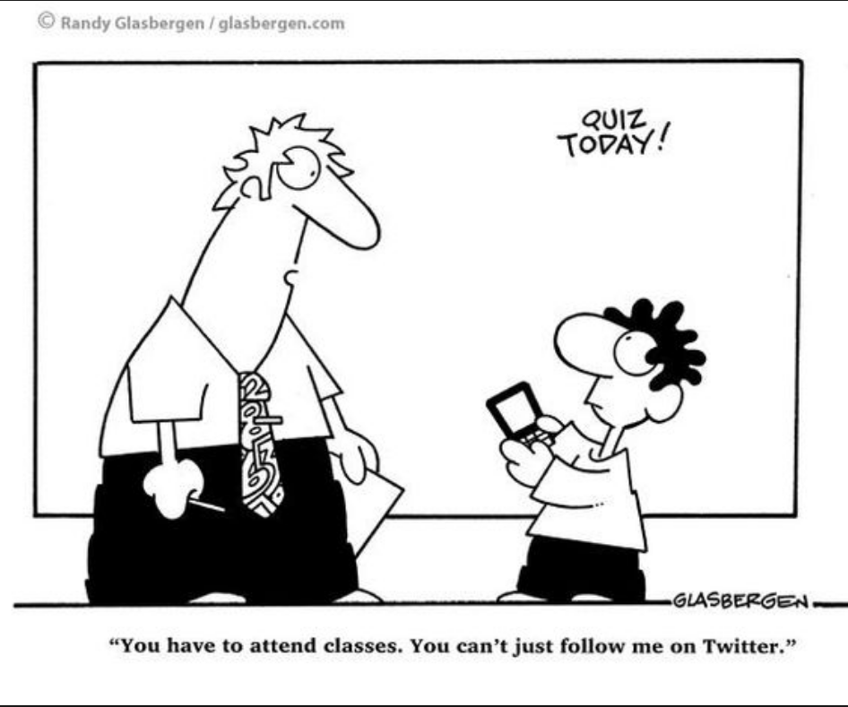

Classroom Behavior
As a member of the University and classroom community, you commit to treating others with respect and consideration. Please practice civility and courtesy in all interactions with your classmates and me. I also expect you to refrain from behaviors that disrupt the class environment and/or are detrimental to your peers’ ability to learn, including

Holding side conversations, even if they’re about whatever we’re discussing | Watching videos
Doing homework during class | Surfing the Internet
Interrupting classmates | Listening to music and/or wearing headphones
Habitually leaving and then returning | Taking photos, including of the board
Making derogatory, dismissive, or mocking comments | Passing notes (handwritten or electronic)
Texting | Using a laptop, lab computer, tablet, phone, or any other technology at any time and for any purpose not explicitly approved

Research shows that students who hand-write their class notes understand and retain information more effectively than those who use a laptop for note-taking. (See https://www.scientificamerican.com/article/a-learning-secret-don-t-take-notes-with-a-laptop/.) Thus, I expect you to take handwritten notes rather than typing, photographing the board, or recording lectures and discussions. (The exception is students whose SARC-approved accommodations include electronic or audio note-taking.)

I occasionally allow use of phones and laptops for in-class activities. If you aren’t sure whether you may use a personal electronic device, please ask. If you are experiencing an emergency and need your phone accessible in case of news, notify me in advance, and leave the phone on vibrate. If you receive an urgent call or text, you may leave the room to complete the communication. At my request, you should be able to produce documentation confirming the emergency.

Academic Integrity
Georgia Southern faculty take academic dishonesty, including plagiarism and falsifying research, extremely seriously. All work you submit for this course must be your own and original (you haven’t submitted it for another class or assignment). You must indicate all content that is not yours, through quotations of direct wording and cited paraphrases of ideas. Please ask if you have questions about proper use and citation of sources. I would rather answer questions ahead of time than address plagiarism!

GSU instructors may utilize a plagiarism prevention technology in some of their course sections. Students may have the option of submitting papers online through a plagiarism prevention service or of allowing the instructor to submit hard copies of their papers. The papers may be retained by the service for the sole purpose of checking for plagiarized content in future student submissions. This verbiage was provided by the GSU Office of Legal Affairs.
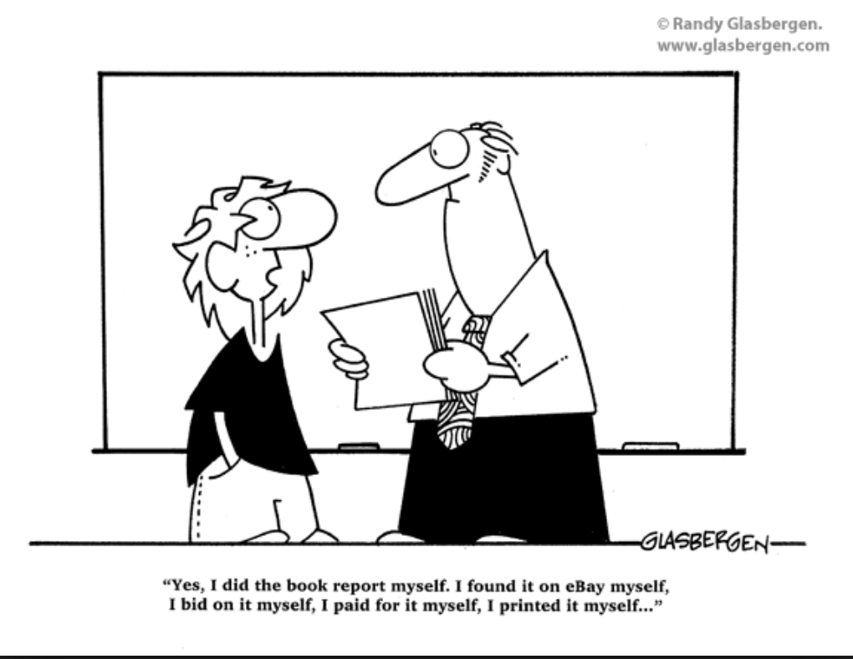

For most drafts and papers, I’ll set up the plagiarism check (turnitin.com) in the Folio dropbox. I will post instructions, and I encourage you to use this program to help avoid inadvertent plagiarism. Remember, however, that you are ultimately responsible for the content of your paper and for any academic dishonesty that occurs, even if turnitin.com does not detect it.

Copyright of lectures and other course materials produced by the instructor is held solely by the instructor. This copyright covers student notes, summaries, or any other copies that exactly reproduce the copyrighted material. Lectures and course materials are made available to students for personal use only and may not be distributed or reproduced for commercial purposes without the express, written permission of the instructor. Students are permitted to share notes on an individual, non-commercial basis for personal use only. Violations of copyright may result in course sanctions, including charges under the Student Conduct Code.

If academic dishonesty occurs, I will assess consequences on a case-by-case basis. Penalties range from deductions and/or mandated revisions to failing the assignment or the course. Plagiarism also must be reported to the Dean of Students Office, which may assign additional consequences.

Other Policies

Grace Policy
Because I realize you have different requirements for every class, you get one “freebie.” The first time you do one of the following, if you meet the conditions here, I’ll waive the consequences:

- Submit an assignment in the wrong file format (eg PDF, Pages), if you submit the paper as a Word document within 24 hours after I post a request for you to resubmit. Note that you are responsible for reading my feedback in a timely manner.
- Fail to submit the printed draft of the required length during the class period prior to the draft workshop, but do submit it to me at least 24 hours before the workshop
- Fail to submit both printed and online copies of your final paper by class time, if you submit both to me within 24 hours of the due date/time
- Forget to include drafts and/or critiques with your final paper, if you provide those materials within 24 hours of the due date/time
- Arrive late to class the day the paper is due because of a printing crisis
- Submit an assignment late due to technical issues, if you provide documentation of those issues by the due date and time. Please note that failure to plan ahead and find a working printer is not a technical issue!

You may not use a freebie to complete a reading response that you forgot about. However, other situations might qualify; we’ll discuss these on a case-by-case basis. Consequences will apply for every incident after the first, so don’t test my patience!


Technology
I expect you to check your Georgia Southern University e-mail account and Folio news at least once every 24 hours and more frequently if you have written me and are awaiting a response. These are the primary means by which I contact you if I need to touch base (to schedule a meeting, reschedule a conference, etc.).

If you have issues with Folio or other technology, please contact the Center for Academic Technology Support (912-478-0882) for assistance. You also can find tutorials on the Folio homepage. While I want to be helpful, I’m not a technology expert, so I refer most questions to CATS.

Please do not wait until an assignment is due to inform me of technical issues. It’s your responsibility to identify and resolve these in a timely manner or to provide documentation of ongoing problems. If you encounter an error while you’re trying to submit an assignment, e-mail me explaining the issue, and attach your work. This is not a substitute method to submit work but rather documentation that you attempted to turn in the assignment on time.

Be sure to save your work to Google drive or a flash drive so you are not restricted to working on a personal computer. Because the university provides you with free access to computers across campus, problems with a personal computer do not constitute a valid reason to submit late work in most cases.

If you use your phone to complete assignments, please proofread very carefully. Regardless of the tools you use, you are ultimately responsible for the content of your paper and for any errors in word usage, grammar, punctuation, or spelling it contains.

FERPA
According to the Family Education Rights and Privacy Act (FERPA), your grades are private, and I cannot discuss them with anyone other than you. This includes coaches, parents, and guardians, unless they have been added to your FERPA list and verify the necessary information to communicate with me regarding you and your grades.

Even if you have added someone to your FERPA list, you are ultimately responsible for all communications regarding your performance in class. I will only discuss your grade, attendance, or other matters via phone if you are included in the call, or through e-mail if you are an active participant in the exchange. In addition, I may opt to speak only with you and not with your representative.

Accommodations for Students with Disabilities
It is university policy to provide, on a flexible and individualized basis, reasonable accommodations to students who have documented physical and learning disabilities. If you have a documented disability, please contact the Student Accessibility Resource Center (sarcboro@georgiasouthern.edu). To receive accommodations, you must register with the SARC, provide documentation, and obtain a letter to share with your professors, outlining the accommodations the SARC has determined for you.

Once you have your accommodation letter, please set up an appointment with me as soon as possible to discuss your needs, expectations, and questions. Because federal guidelines require that I honor accommodations recommended by the SARC, it’s in your best interest to contact them as early as possible, before major assignments are due. I will work with them and you to meet your needs but cannot retroactively adjust grades. In addition, professors can provide only the accommodations specified in your letter from the SARC. If you believe you qualify for and would benefit from additional or different accommodations, please contact the SARC immediately.
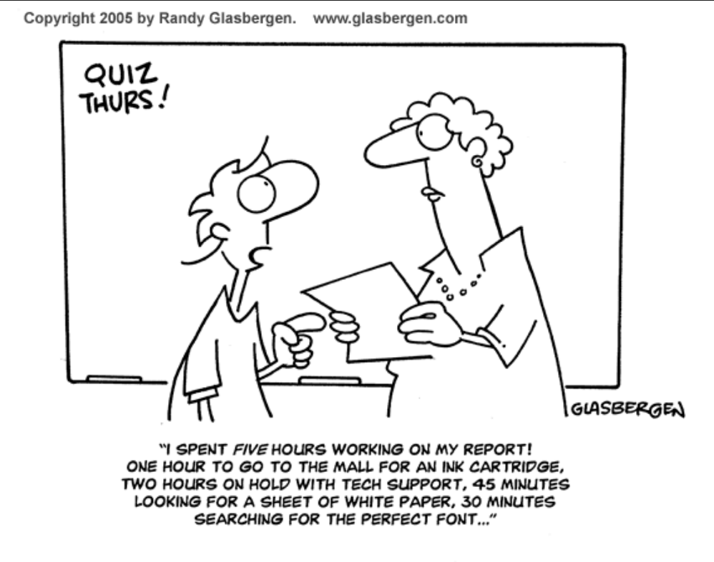
Campus Carry
For information, visit http://bf.georgiasouthern.edu/
publicsafety/campus-carry-information/.

GSU Writing Requirements/Regents Requirements
Students who fail to earn at least a “C” in either ENGL 1101 or 1102 will be required to repeat the course in the next term in which the student is enrolled. Faculty will develop with the student an action plan to facilitate the student’s success in the course.

Important Dates
To maintain flexibility, I post assignment due dates to the course website rather than including them on the syllabus (which I can’t alter after distributing, except with special dispensation from the provost). Please note that the Folio schedule is subject (and likely) to change throughout the term. However, here are university and course dates that should remain firm:

Date
August 13 | First day of classes for fall semester
August 13-16 | Schedule adjustment period
September 3 | Labor Day—no class
September 28 | Last day for me to submit academic alerts
October 8 | Last day to withdraw without academic penalty
November 12-29 | SRIs (course evaluations) and Student Perception Surveys
November 30 | Last day of classes for fall semester

